**Q1:**

package Q_01;  
  
public class Q_01 {  
 public static void main(String[] args) {  
 for (int i = 10; i < 50; i++) {  
 System.*out*.print(i + " ");  
 if ((i + 1) % 10 == 0) {  
 System.*out*.println();  
 }  
 }  
 }  
}

**Output:**

**Q2:**

package Q_02;  
import java.util.Scanner;  
  
public class Q_02 {  
 public static int countDigits(int number) {  
 return String.*valueOf*(Math.*abs*(number)).length();  
 }  
 public static void main(String[] args) {  
 Scanner scanner = new Scanner(System.*in*);  
 int number;  
 do {  
 System.*out*.print("Enter an integer (negative to stop): ");  
 number = scanner.nextInt();  
 if (number >= 0) {  
 System.*out*.println("Number of digits: " + *countDigits*(number));  
 }  
 } while (number >= 0);  
 }  
}

**Output:**

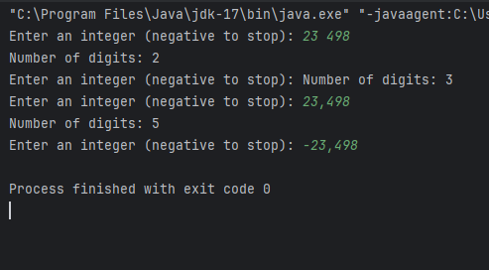

**Q3:**

package Q_03;  
import java.util.Scanner;  
  
public class Q_03 {  
 public static void main(String[] args) {  
 Scanner scanner = new Scanner(System.*in*);  
 System.*out*.print("Enter a number: ");  
 int n = scanner.nextInt();  
  
 for (int i = 1; i <= 10; i++) {  
 System.*out*.println(n + " x " + i + " = " + (n * i));  
 }  
 }  
}

**Output:**

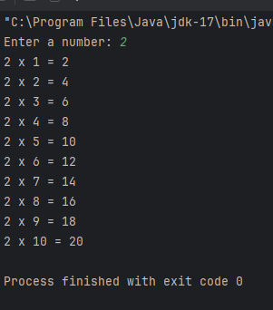

**Q4:**

package Q_04;  
import java.util.Scanner;  
  
public class Q_04 {  
 public static void main(String[] args) {  
 Scanner scanner = new Scanner(System.*in*);  
 System.*out*.print("Enter number of rows: ");  
 int rows = scanner.nextInt();  
  
 for (int i = 1; i <= rows; i++) {  
 for (int j = i; j < rows; j++) {  
 System.*out*.print(" ");  
 }  
 for (int k = 1; k <= (2 * i - 1); k++) {  
 System.*out*.print("*");  
 }  
 System.*out*.println();  
 }  
 }  
}

**Output:**

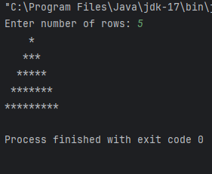

**Q5:**

package Q_05;  
import java.util.Scanner;  
  
public class Q_05 {  
 public static void main(String[] args) {  
 Scanner scanner = new Scanner(System.*in*);  
 System.*out*.print("Enter a word or phrase: ");  
 String input = scanner.nextLine().replaceAll("[^a-zA-Z0-9]", "").toLowerCase();  
  
 String reversed = new StringBuilder(input).reverse().toString();  
  
 if (input.equals(reversed)) {  
 System.*out*.println("It is a palindrome.");  
 } else {  
 System.*out*.println("It is not a palindrome.");  
 }  
 }  
}

**Output:**

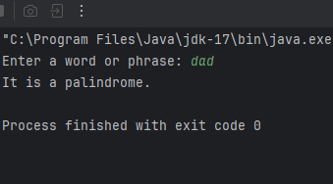

**Q6:**

package Q_06;  
import java.util.Scanner;  
import java.util.Random;  
  
public class Q_06 {  
 public static void main(String[] args) {  
 Random random = new Random();  
 Scanner scanner = new Scanner(System.*in*);  
  
 int numberToGuess = random.nextInt(100) + 1;  
 int guess;  
  
 do {  
 System.*out*.print("Guess the number (1-100): ");  
 guess = scanner.nextInt();  
  
 if (guess < numberToGuess) {  
 System.*out*.println("Higher!");  
 } else if (guess > numberToGuess) {  
 System.*out*.println("Lower!");  
 } else {  
 System.*out*.println("Correct! Well done!");  
 }  
 } while (guess != numberToGuess);  
 }  
}

**Output:**

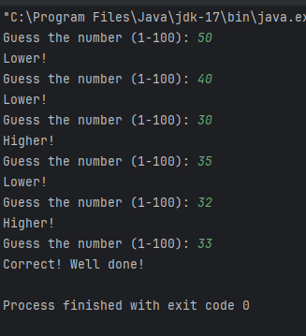

**Q7:**

package Q_07;  
import java.util.Scanner;  
  
public class Q_07 {  
 public static void main(String[] args) {  
 Scanner scanner = new Scanner(System.*in*);  
  
 System.*out*.print("Enter a sentence: ");  
 String sentence = scanner.nextLine();  
  
 System.*out*.print("Enter the word to be replaced: ");  
 String wordToReplace = scanner.nextLine();  
  
 System.*out*.print("Enter the replacement word: ");  
 String replacement = scanner.nextLine();  
  
 String modifiedSentence = sentence.replaceAll("\\b" + wordToReplace + "\\b", replacement);  
 System.*out*.println("Modified sentence: " + modifiedSentence);  
 }  
}

**Output:**

